ASSIGNMENT

SIMPLE STORAGE SERVICE (S3)

WORKING WITH S3 AND PERMISSION

STEPS IN WORKING WITH S3 AND PERMISSION:

1. **Logon on to console and click on s3**
2. **Click on create bucket enter bucket name yahoo999 and select region MUMBAI and click create**
3. **Upload a video file and right click on it click on public and select propertie**
4. **Copy paste the url on the browser to access the uploaded file**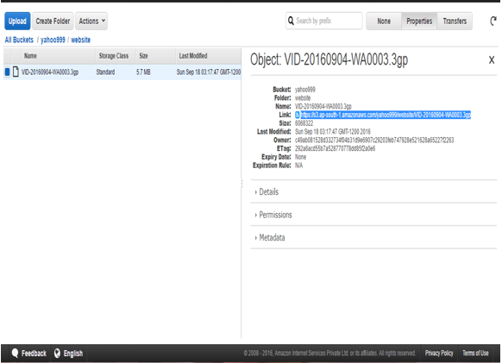

**5) Similarly upload a jja.html file to the bucket yahoo999**

**6) go to yahoo999>properties >static website hosting>enable web site hosting give the index name as jja.html**

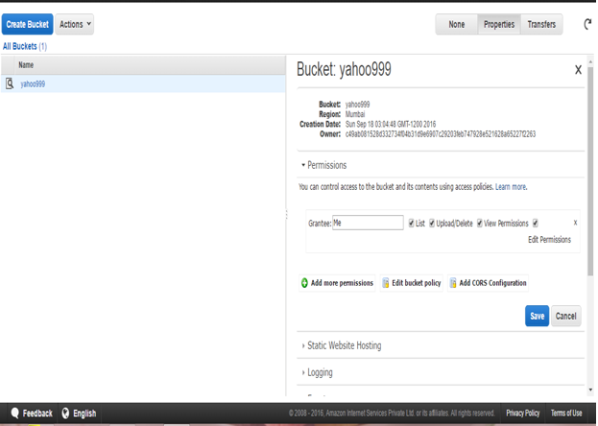

**7) yahoo999>bucket policy>aws policy generator**

**8) effect >allow and aws policy>s3 bucket policy**

**9) principal>* and actions>all**

**10) ARN>arn:aws:s3:::yahoo999**

**11) click on save two times**

**12) Right click on yahoo999>properties> add more permissions>everyone>save**

**13) Right click on jja.html>properties> add more permissions>everyone>save**

**14) jja.html >copy paste the url on the right top to access the static web page as below**

